Chapter 5, Solution 47.

Using eq. (5.18),
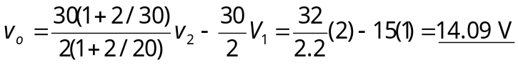

= 14.09 V.

